AGRIBUSINESS DATA ANALYSIS
Data Cleaning and Preprocessing Strategy

Student Name: Rishiwaran K
Register Number: 23BIT037
Institution: Info Institute of Engineering Department: B.Tech Information Technology Project Area: Agribusiness data analysis

Executive Summary
Agribusiness datasets may contain missing prices, inconsistent crop and market names, duplicate records, mixed units, incorrect dates, and extreme values. If these issues are ignored, charts and forecasts may be misleading. This report proposes a repeatable workflow for preparing public agricultural data, initially focusing on onion, tomato, and rice market information in India. It combines data profiling, standardization, duplicate checks, documented missing-value handling, outlier investigation, validation, and reproducible saving. The plan keeps raw files unchanged and records every important decision.

Objective and Scope
The objective is to design a practical data-cleaning and preprocessing strategy for a hypothetical agribusiness dataset. The strategy should make data suitable for reliable descriptive analysis, comparisons, and later forecasting.
- Geographic scope: India; state- or market-level analysis where compatible data are available.
- Initial crop set: onion, tomato, and rice.
- Likely fields: observation date, state, market, crop, variety, arrivals, minimum price, maximum price, modal price, rainfall, production, area, and yield.
- Output: a clean analysis dataset, data dictionary, quality report, decision log, workflow diagram, and reproducible code/notebook.
Important scope rule: only combine datasets when their crop definitions, location identifiers, time periods, and units are compatible. If compatibility cannot be established, analyze them separately.

Common Data Quality Problems in Agribusiness
Problem | Example | Why it matters | Detection method
Missing values | Modal price is blank for a market-date | Reduces usable  observations and can bias summaries | Missing-value counts and  percentage by column/month
Inconsistent formats | Dates appear as 05/10/2026 and 2026-10-  05 | Can cause wrong sorting or failed merges | Parse dates; inspect invalid conversions
Inconsistent labels | “Tomato”, “tomatoes”, “TOMATO” | Creates duplicate categories | Trim spaces, lowercase for  matching, use a mapping table
Duplicate rows | Same crop-market-date repeated after downloading  overlapping files | May double-count arrivals or prices | Check full-row duplicates and business-key  duplicates
Mixed units | Price in ₹/quintal in one file and ₹/kg in another | Comparisons become incorrect | Review metadata and  normalize units before merging
Outliers | A price far above nearby observations | May be a real event or a recording error | Range rules, time plots, IQR/z-score flags, source  checks
Invalid values | Negative arrivals or max price below min price | Violates domain logic | Rule-based validation
Different time grain | Daily market prices merged  directly with annual production | Can multiply rows or imply false precision | Aggregate to a common  time grain and document method
Encoding/decimal issues | “1,250” read as text or decimal comma misread | Numerical calculations fail | Inspect data types and parse using source-specific  rules
Changing definitions | Market name or commodity code changes over time | Breaks trend consistency | Keep a reference mapping and source notes

Proposed Data Quality Framework
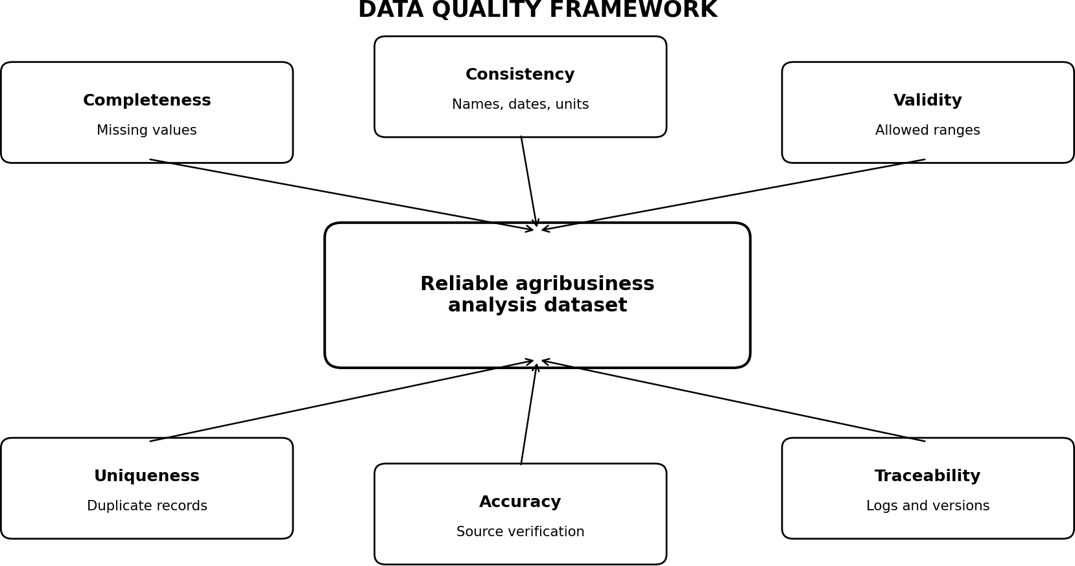

The dataset is considered ready only after checks for completeness, consistency, validity, uniqueness, accuracy, and traceability have been performed and documented.

Data Sources and Source Register
Use public or recognized sources and record the exact dataset page, download date, file name, coverage, units, and limitations. Availability and field definitions should be verified when collecting the data; this report does not claim that a specific dataset has already been downloaded.

Potential source | Potential information | Checks before use
AGMARKNET / Directorate of Marketing & Inspection | Mandi arrivals and wholesale prices | Confirm market, commodity, date, price type, and unit definitions
data.gov.in | Open government agriculture and market datasets | Read dataset metadata, licence,  update frequency, and field descriptions
Directorate of Economics & Statistics  / Agriculture Ministry | Area, production, and yield statistics | Check crop year, state coverage, and measurement units
India Meteorological Department (IMD) | Rainfall and weather observations | Check station/location, date range, and aggregation method
FAOSTAT | Agricultural production and related indicators | Use for broader comparison; definitions may differ from Indian  datasets

Source register template:

Field | What to record
Dataset ID / filename | Unique name, original filename, and file type
Publisher and dataset title | Official source and exact dataset name
Access details | Dataset page or URL and download date
Coverage | Crop, geography, dates, and frequency
Units / definitions | Price unit, quantity unit, price type, and definitions
Limitations | Missing periods, revisions, coverage gaps, or known changes
Processing version | Script/notebook version and output filename

Step-by-Step Data Cleaning Plan

Step 1 — Define the target structure
Decide the row meaning before cleaning. Example: one row represents one crop × market × observation date. Write down required columns, units, valid ranges, and key fields.

Step 2 — Preserve raw data
Save original downloads in a read-only/raw folder. Never overwrite them. Make a working copy for cleaning and record the filename, source, download date, and file size.

Step 3 — Inspect and profile
Check number of rows/columns, column names, data types, missing counts, unique categories, duplicates, minimum/maximum values, and date coverage. Generate a short profile report.

Step 4 — Standardize column names and data types
Use consistent names such as observation_date, crop, market, arrivals, min_price, max_price, and modal_price. Parse dates and numeric fields carefully; keep a list of values that fail conversion.

Step 5 — Standardize categories and units
Trim leading/trailing spaces, normalize capitalization for matching, and use an approved mapping table for crop/state/market names. Convert units only when the original unit is known and conversion is valid.

Step 6 — Identify duplicates
Check exact duplicate rows first. Then check business keys such as crop + market + date + variety + price type. Do not automatically delete every repeated key: first determine whether the rows are duplicate downloads or separate legitimate records.

Step 7 — Handle missing values
Measure the amount and pattern of missingness. Investigate why the value is missing. Use deletion only when appropriate; impute only when the method is defensible and label imputed values.

Step 8 — Detect and investigate outliers
Use domain rules, time-series plots, and statistical flags. Compare flagged records with the source or nearby observations. Correct only confirmed errors; retain plausible real events.

Step 9 — Validate logical relationships
Check min_price ≤ modal_price ≤ max_price where the source definitions make this relationship appropriate; arrivals and production should not be negative; dates should fall within expected coverage.

Step 10 — Merge datasets carefully
Merge using compatible crop, location, and period keys. Check join type and row counts before/after merging. Aggregate daily market data to monthly summaries if needed before joining with monthly or annual data.

Step 11 — Create analysis-ready features
Only after cleaning, derive month, season, percentage change, moving average, price volatility, or yield. Avoid using future values in features for forecasting.

Step 12 — Save, test, and document
Export cleaned data separately. Save scripts, data dictionary, quality summary, decision log, and final row counts. Re-run from raw data to check reproducibility.

Missing-Value Handling Strategy
Missing data should not be filled automatically. First identify which fields are missing, how much is missing, and whether the absence has a known reason. The choice depends on the field and intended analysis.

Situation | Recommended treatment | Caution
A small number of rows lack a non-essential note field | Leave blank or exclude that field from analysis | Do not discard useful records unnecessarily
Price missing for a market-date | Check source and nearby records; keep missing if unverified | Do not copy a neighbouring market price as if observed
Short gap in a continuous time series | For exploratory plots, consider time  interpolation only if justified; mark as imputed | Do not use interpolation blindly for volatile market prices
Missing rainfall for a station/date | Check alternate official data or aggregate only with a defensible  method | Rainfall varies by location; avoid using a distant station without  justification
Target value missing for model training | Usually exclude those rows from  supervised training or use a justified method | Never use the target from the future to fill a past value
Missing category such as crop or market | Resolve from source/reference code if possible; otherwise mark unknown or  exclude for key analysis | Do not guess labels from unrelated fields

Hypothetical example: missing modal price
Suppose monthly modal prices for one market are ₹1,800, ₹1,900, blank, and ₹2,100 per quintal. The blank value should first be checked against the source. If it cannot be verified, preserve it as missing for the primary analysis. For a clearly labelled demonstration only, linear interpolation would estimate the third value as (₹1,900 + ₹2,100) / 2 = ₹2,000. This estimate must be marked as imputed and not presented as an observed market price.
Rule: preserve the original value in a raw column or raw file, create a separate cleaned/imputed field when needed, and record the method.

Outlier Detection and Treatment
An outlier is an observation that differs substantially from the rest. In agriculture, an unusual price may reflect a genuine shortage, weather shock, transport disruption, festival demand, or sudden market change. Therefore, a statistical flag is a signal to investigate—not automatic proof of an error.

Domain and logical checks
    - Flag negative prices, negative arrivals, impossible dates, or invalid units.
    - Flag cases where minimum price exceeds maximum price, after confirming the source’s definitions.
    - Compare unusual values with source records, nearby dates, and comparable markets.

Interquartile Range (IQR) method
Calculate Q1 (25th percentile), Q3 (75th percentile), and IQR = Q3 − Q1. A common screening rule flags values below Q1 − 1.5 × IQR or above Q3 + 1.5 × IQR. This is a flagging rule, not a rule that values must be deleted.

Worked hypothetical example
Step | Calculation | Result
Sample values (₹/quintal) | 1,800; 1,900; 2,000; 2,100; 5,000 | Illustrative only
Q1 and Q3 (illustrative quartiles) | Q1 = 1,900; Q3 = 2,100 | IQR = 200
Lower fence | 1,900 − 1.5 × 200 | 1,600
Upper fence | 2,100 + 1.5 × 200 | 2,400
Flagged value | 5,000 is above 2,400 | Investigate source; do not delete automatically

If ₹5,000 is a data-entry error and the source confirms the correct value, correct it with a recorded reason. If the source confirms a genuine price spike, retain it and explain the event if evidence is available.

Z-score option
For data that are approximately normally distributed, z = (value − mean) / standard deviation can identify unusually distant observations. A threshold such as |z| > 3 is sometimes used for screening, but skewed market prices may not suit this assumption. IQR and time-series plots are often easier starting points for beginners.

Standardization, Normalization, and Filtering
Technique | Purpose | Example / rule | When to use
Standardization | Make labels, dates, and units consistent | Map “Tomato ” and “TOMATO” to one  approved crop label | Before grouping or merging
Normalization (min-max) | Scale a numeric feature to 0–1 | x' = (x − min) / (max − min) | When a model or  comparison benefits from a bounded scale
Z-score scaling | Express values in standard-deviation units | z = (x − mean) / SD | Some models; fit parameters on training data  only
Filtering | Select records matching valid study scope | Keep selected crops,  approved markets, and target dates | When rows fall outside the defined project scope
Aggregation | Summarize records at a common time grain | Daily modal prices →  monthly median or mean, chosen and documented | Before joining with monthly data

Important: normalization is not the same as fixing errors. Scale features only after cleaning and split the data chronologically before fitting scaling parameters for forecasting, so information from the test period does not leak into training.

Preprocessing Workflow Diagram
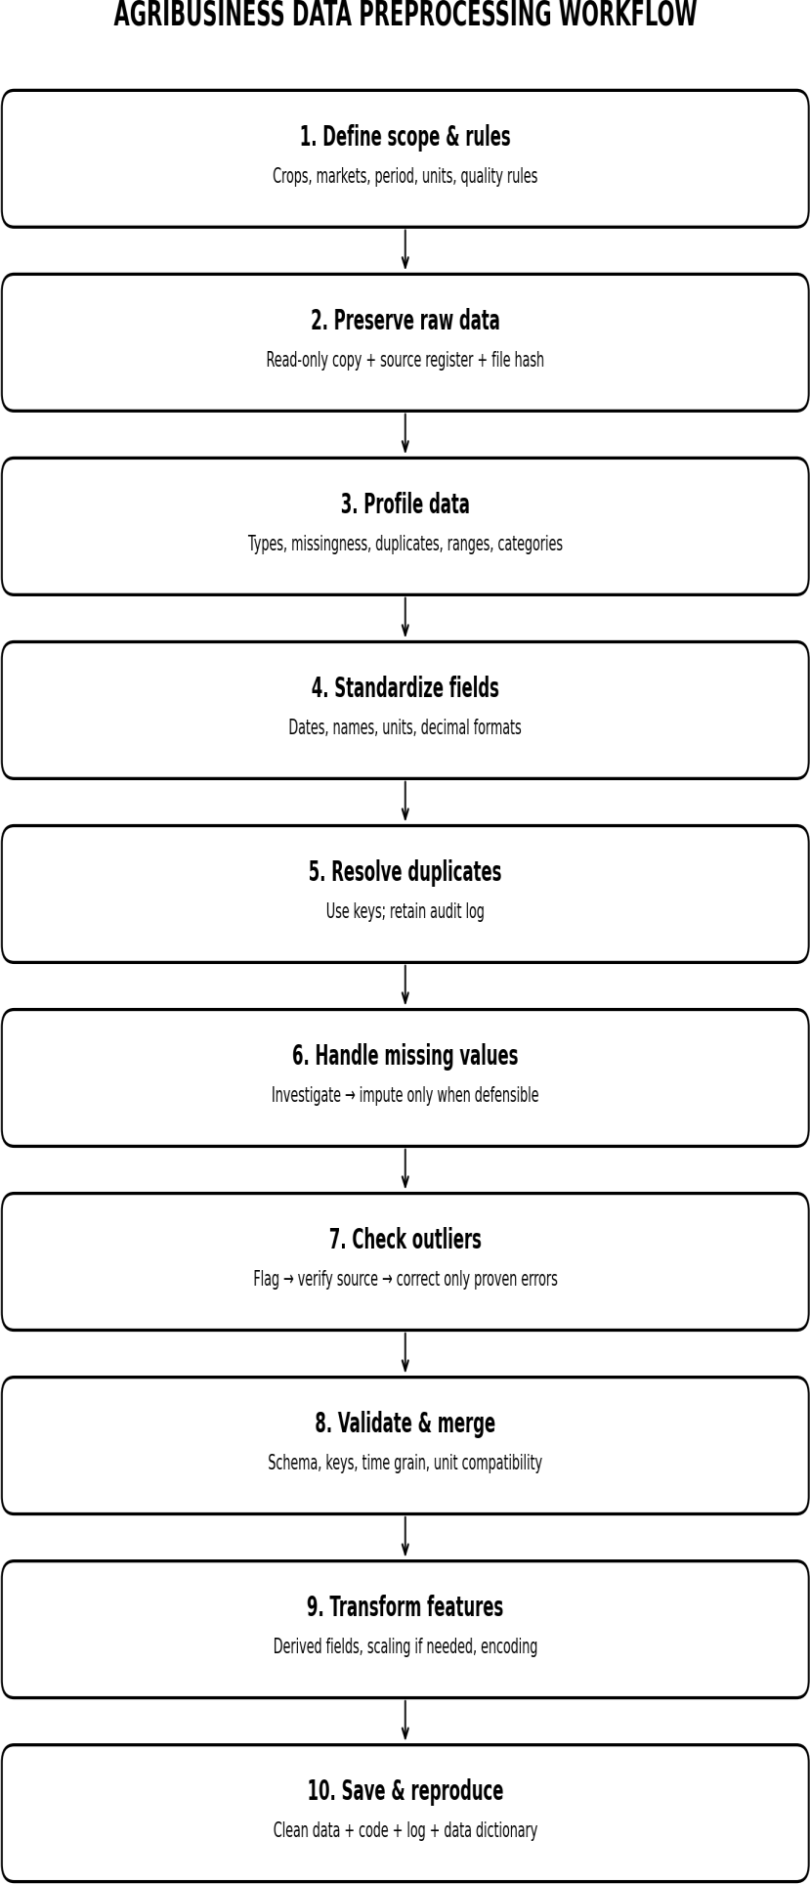

The order is intentional: preserve and inspect data before modifying it; investigate before imputing or deleting; validate again after transformations; and keep the raw data unchanged.

Validation Checklist and Acceptance Criteria
Check | Acceptance rule / evidence
Raw files preserved | Original files remain unchanged; filenames and download dates recorded
Schema and types | Required columns present; dates and numeric fields parse  correctly or exceptions are logged
Missingness | Missing count and percentage reported for each important column; decisions documented
Duplicates | Exact duplicates reviewed; business-key duplicates  investigated rather than blindly removed
Units and labels | Units are explicit; crop/market names use approved mappings
Domain validity | Negative quantities/prices and impossible date/value  relationships are flagged and resolved or documented
Outliers | Statistical flags reviewed against source/nearby data; no automatic unexplained deletion
Merge integrity | Join keys compatible; row counts before/after merge checked; unexpected row multiplication investigated
Reproducibility | Same script and same input files produce the same cleaned output and summary
Final handover | Clean file, data dictionary, quality report, processing log, code/notebook, and limitations included

Suggested reporting metrics: rows before and after cleaning; number and percentage of missing values by field; duplicate rows removed or retained with reasons; number of outliers flagged and confirmed errors; number of rows imputed; and number of records excluded by scope filters.

Reproducibility and Audit Trail
Reproducibility means another person can repeat the process and understand why each change was made. It improves trust, helps find mistakes, and makes future updates easier.
- Keep raw/, processed/, reports/, and notebooks/ folders separate.
- Record software/library versions and the date the workflow was run.
- Use a fixed order of cleaning steps and stable mapping files.
- Log each decision: field, issue, action, reason, number of affected rows, and date.
- Use a fixed random seed for any method that uses randomness.
- Keep training and test periods separate for forecasting; do not use future observations during cleaning or feature creation.
- Version the cleaning script and data dictionary. Store only data that the source licence permits you to share.

Example decision-log entry
Date | Field | Issue | Action | Reason / evidence | Rows affected
2026-10-17 | crop | Extra spaces and capitalization | Mapped to  approved crop labels | Text formatting  only; mapping saved | 12
2026-10-17 | modal_price | One value outside IQR  fence | Flagged; checked source  before decision | No correction until source is  verified | 1
2026-10-17 | observation_date | Mixed date formats | Parsed to YYYY-MM-DD | Source format recorded | All rows

Tools and Implementation Plan
Tool | Use
Python | Main programming language for repeatable cleaning
Pandas | Read files, inspect missing values, standardize columns, detect duplicates, merge datasets
NumPy | Numerical calculations and missing-value handling
Matplotlib | Missingness, trend, distribution, and outlier plots
Jupyter Notebook / Google Colab | Documented, step-by-step analysis environment
Excel / spreadsheet viewer | Quick visual inspection and review of source metadata
Git / GitHub (if permitted) | Version code, mapping tables, and documentation; avoid uploading restricted or sensitive raw data

Limitations and Risk Controls
Risk | Control
Public datasets may be incomplete or revised | Record download date and dataset version; rerun validation after updates
Different sources define prices or crops differently | Read metadata; maintain a data dictionary; do not merge incompatible definitions
Outlier may be a real market event | Verify against source and nearby observations; retain valid unusual values
Imputation may hide genuine shortages or volatility | Limit imputation, label it, and compare results with and without imputed rows
Model leakage from future data | Use chronological splits and fit transformations on training data only
Code or raw data may be shared improperly | Check data licence and upload only permitted files

